Chartering Report
  - Acme-Starters

Workgroup Overview
Project Name: Acme-Starters
Subject: Diseño y Pruebas II
Workgroup Manager: Manuel Zoilo Buzón Muñoz

Workgroups Members
Surname, Name | Rol | US mail | uvus
Buzón Muñoz, Manuel Zoilo | Manager | manbuzmun@alum.us.es | manbuzmun
Prieto Fernández, Juan | Developer | juaprifer@alum.us.es | SDL0657
Orta Pérez, Manuel | Developer | Manortper1@alum.us.es | manortper1
Lavado Corredera, Manuel | Developer | manlavcor@alum.us.es | manlavcor

Recruitment Summary
The members of this workgroup were recruited by the manager through the official recruiting forum of the subject.
The recruitment process focused on motivation, availability, teamwork skills, and commitment to achieving a high academic performance.
The recruitment thread can be found at the following link:
https://ev.us.es/ultra/courses/_98112_1/cl/outline
All selected members explicitly confirmed their willingness to collaborate actively and responsibly in the project.

Commitment Statement
All members of the Acme-Starters workgroup formally commit to:
- Working collaboratively and respectfully throughout the duration of this subject.
- Actively contributing to the tasks assigned to them.
- Having read, understood, and accepted the official syllabus of the subject.
- Understanding the evaluation and grading procedures, including deadlines, deliverables, and assessment criteria.
- Aiming collective to achieve a final mark of at least B in this subject.
This commitment is binding for all members of the workgroup.

Performance Indicators
Work Done vs. Work Pending (Task Completion)
- Indicator: The percentage of tasks completed versus the total tasks assigned.
- Performing Well: A member who completes at least 90% of their assigned tasks on time and according to the established requirements.
- Performing Poorly: A member who completes less than 50% of their assigned tasks or consistently misses deadlines.
Quality of Work (Deliverables and Results)
- Indicator: The quality of the work submitted, assessed based on predefined standards and peer reviews.
- Performing Well: A member whose work meets or exceeds the quality standards set by the team and the lecturer. This includes accuracy, clarity, and thoroughness.
- Performing Poorly: A member whose work frequently requires revision, is incomplete, or is of poor quality, needing more than two rounds of feedback to be considered acceptable.
Peer and Lecturer Ratings
- Indicator: Feedback from both peers and the lecturer, using a rating scale (e.g., 1 to 5).
- Performing Well: A member who receives an average rating of 4 or higher from peers and the lecturer.
- Performing Poorly: A member who consistently receives ratings below 3 from peers or the lecturer, indicating a lack of contribution or issues with collaboration and communication.

Timeliness and Attendance
- Indicator: The member's attendance in workgroup meetings and the timeliness of their contributions.
- Performing Well: A member who attends all scheduled meetings and is punctual for deadlines, actively contributing during discussions.
Performing Poorly: A member who frequently misses meetings or is often late, and whose contributions are either late or minimal.

Rewards for Good Performance
Workgroup members who consistently perform well will be rewarded with:
- Positive recognition within the group
- Preference in task selection for future milestones
- Support and endorsement from the manager in peer evaluations
- Consideration for leadership roles in future projects

Admonishment for Bad Performance
Workgroup members who perform poorly will be subject to the following measures:
- First warning: Informal verbal or written warning and clarification of expectations.
- Second warning: Formal written warning and reassignment or reduction of responsibilities.
- Final warning: Evaluation for possible removal from the workgroup.
All warnings will be documented and communicated clearly.

Conditions for Firing a Workgroup Member
A workgroup member may be fired if one or more of the following conditions apply:
- Persistent failure to meet minimum performance standards after multiple warnings.
- Repeated absence from meetings without justification.
- Lack of communication over an extended period.
- Behaviour that negatively affects the workgroup or violates academic integrity.
A fired student may choose to:
- Continue working individually on the subject, or
- Drop out of the subject, according to the official regulations.
A fired student will be forbidden to use this group’s repository.

Acceptance
By participating in the Acme-Starters workgroup, all members acknowledge and accept the contents of this Chartering Report.
Signed by all workgroup members:
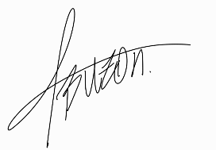
- Buzón Muñoz, Manuel Zoilo

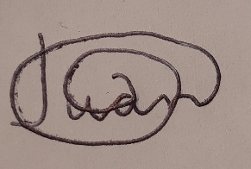
- Prieto Fernández, Juan

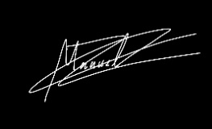
- Orta Perez Manuel

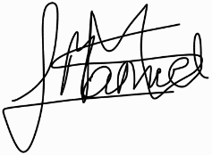
- Lavado Corredera Manuel

Date: 06/02/2026

